PIERCE PACERS SOFTBALL 2024 REGISTRATION
Player’s Name ____________________________________________________
Parent(s) Name_________________________________________
Address________________________________________________
DOB_______________/Current Grade_____________/Current Age______
Preferred & Alternate Phone Number _____________________________________
Preferred Email____________________________________________
Emergency Contact & Phone _________________________________
Allergies/Known Medical Conditions ________________Shirt Size (Youth/Adult) _________
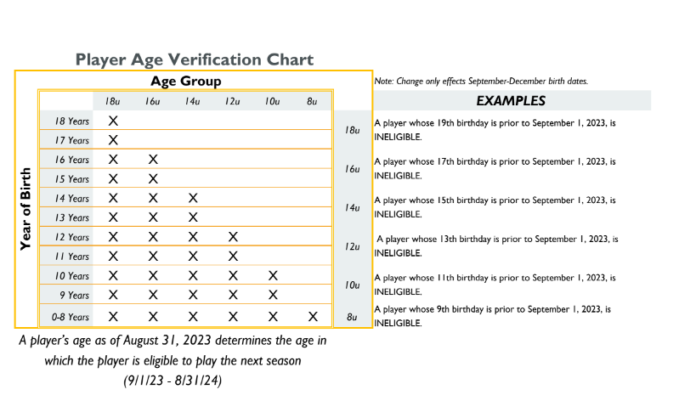
I, the parent or legal guardian of the participant, hereby authorize the coaches, assistant coaches, or parents of the team members acting as supervisors, as my agents, to consent to medical examination or treatment. If there is an emergency and I cannot be reached, please contact my emergency contact listed above.
I, the parent or legal guardian of the participant, give my consent and agree to release and hold harmless the City of Pierce, Pierce Softball Backers, its officials, coaches, and representatives from any claim arising out of the injury to the participant. I also hold the City of Pierce, Pierce Softball Backers, its officials, coaches, and representatives harmless from any claim arising out of injury or conditions caused by religious or philosophical belief or otherwise.
Parent’s Signature & Date ________________________________

-USA Softball implemented a NEW Age Chart for the 2024 Season(NE chart on front of form)
DUE FEBRUARY 10th, 2024-LATE FEE $15 AFTER THAT DATE, NO REFUND AFTER March 15th, 2024
YOUR PLAYER WILL BE UNABLE TO PARTICIPATE IN PRACTICE OR GAMES UNTIL ALL FEES ARE COLLECTED.
PLEASE RETURN TO YOUR CHILD’S SCHOOL OFFICE OR PIERCE CITY OFFICES BY FEBRUARY 10TH!

--------------------------------------------------------------------------------------------------------------------------
-Keep bottom portion for your records, return top half with registration fees-
-8U Pacers will again play Kelly’s League (Norfolk) 1 night/week(Mondays nights in past)
-Game schedules will not be out until mid-May, with games to begin late May
-”LIKE” our Pierce Pacers Softball FB page & watch piercepacers.com website for updates
**Watch facebook for future date of a Parent’s meeting regarding upcoming 2024 season**
REGISTRATION FEE- 12U-18U $100 FOR SINGLE CHILD (Players who are already or turn 18 during season must complete Safe Sport training to be eligible (pierce.pacers.softball@gmail.com for details)
-8U & 10U $70 FOR SINGLE CHILD *EACH ADDITIONAL CHILD $50 (8U & UP Only for Discount)*
-6U Softball: 6U Shirt & Instructional Practices Only $25/child (THIS IS NOT TBALL)
NEW THIS SEASON:
**Concession Stand & Jersey Deposit: Each FAMILY 8U-18U must submit a separate check for $100 as a deposit with this registration. This is being implemented because 8U-18U have NEW JERSEYS for the 2024 season. Additionally, to help with concession stand worker coverage. If your family works the indicated amount of shifts needed, your check will be returned/shredded. If your family does NOT work the assigned shifts and/or your child’s jersey is not returned in good condition your check will be cashed.**

