PIERCE PACERS SOFTBALL 2025 REGISTRATION

***(HS TEAM ONLY-EXPLANATION ON 2ND PAGE)***



Player’s Name ____________________________________________________

Parent(s) Name_________________________________________

Address________________________________________________

DOB_______________/Current Grade_____________/Current Age______

Preferred & Alternate Phone Number _____________________________________

Preferred Email____________________________________________

Emergency Contact & Phone _________________________________

Allergies/Known Medical Conditions ________________Shirt Size (Youth/Adult) _________

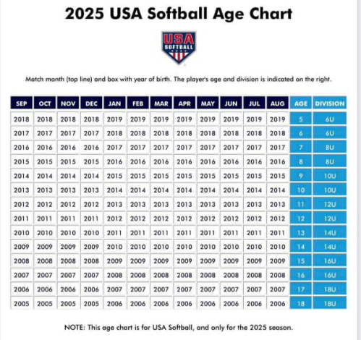

I, the parent or legal guardian of the participant, hereby authorize the coaches, assistant coaches, or parents of the team members acting as supervisors, as my agents, to consent to medical examination or treatment. If there is an emergency and I cannot be reached, please contact my emergency contact listed above.

I, the parent or legal guardian of the participant, give my consent and agree to release and hold harmless the City of Pierce, Pierce Softball Backers, its officials, coaches, and representatives from any claim arising out of the injury to the participant. I also hold the City of Pierce, Pierce Softball Backers, its officials, coaches, and representatives harmless from any claim arising out of injury or conditions caused by religious or philosophical belief or otherwise.

**Parent’s Signature & Date** ________________________________

***High School Age Team Registrations Due December 16th, 2024***

***(At this time, the HS Team will consist of incoming Freshman (2025-2026 school year)-18yo girls eligible to play according to the age chart on front)***

**\*Registrations for younger age teams will be sent home from school *following Christmas break*\***

YOUR PLAYER WILL BE UNABLE TO PARTICIPATE IN PRACTICE OR GAMES UNTIL ALL FEES ARE COLLECTED.

**--------------------------------------------------------------------------------------------------------------------------**

***-Keep bottom portion for your records, return top half with registration fees-***

**-Game schedules will not be out until mid-May, with games to begin late May**

**-Pacers High School team normally plays 4-5 tournaments/season including districts & state**

**-”LIKE” our Pierce Pacers Softball FB page & watch piercepacers.com website for updates**

**\*\*There will again be a Parent’s meeting regarding the 2025 season (spring 2025)\*\***

**REGISTRATION FEE-** HS Team ***$100*** FOR SINGLE CHILD (Players who are already or turn 18 during season must complete **Safe Sport** training to be eligible ([pierce.pacers.softball@gmail.com](mailto:pierce.pacers.softball@gmail.com) for details)

\****EACH ADDITIONAL CHILD* $50**

***\*\*Concession Stand & Jersey Deposit***: Each FAMILY 8U-18U must submit a ***separate check*** for ***$100 as a deposit*** with this registration. This is being implemented to help prolong the life of the jerseys. Additionally, to help with concession stand worker coverage. If your family works the indicated amount of shifts needed, your check will be returned/shredded.  **If your family does NOT work the assigned shifts *and/or* your child’s jersey is not returned in good condition your check will be cashed.\*\***